Task 5 :
Filters and JQL: Advanced Search for Better Visibility - 4 hour(s)
- Using Basic Search and Quick Filters in Jira
- Creating and Saving Filters in Jira for Quick Access
- JQL Basics: What is Jira Query Language and Why It Matters
- Time-Based JQL Queries: Finding Issues by Date and Time
- Link-Based and Hierarchy JQL Queries for Advanced Filtering

Using Basic Search and Quick Filters in Jira ::
Jira provides powerful search capabilities that help users quickly find, track, and manage issues. Two commonly used features are Basic Search and Quick Filters. These tools allow users to locate issues efficiently without requiring advanced query knowledge.
Rule of thumb :
Planning & analysis : Basic Search
Daily work & standups : Quick Filters
1. Basic Search in Jira: Basic Search is a user-friendly search option in Jira that allows users to find issues using simple dropdown selections instead of complex queries.
Hands on :
- Open Jira.
- Click on Issues in the top navigation bar.
- Select Search for issues.
- Ensure Basic Search mode is selected (not JQL).
2. Quick Filters in Jira : Quick Filters are predefined filters available on Jira boards (Scrum or Kanban) that allow users to instantly narrow down issues displayed on the board.
Hands on :
- Open a Jira board.
- Locate Quick Filters at the top of the board.
- Click a filter to apply it instantly.
Common Quick Filters
- Only My Issues – Shows issues assigned to the logged-in user
- Recently Updated – Displays recently modified issues
- High Priority – Shows critical or high-priority issues
- Bugs Only – Displays only bug-type issues

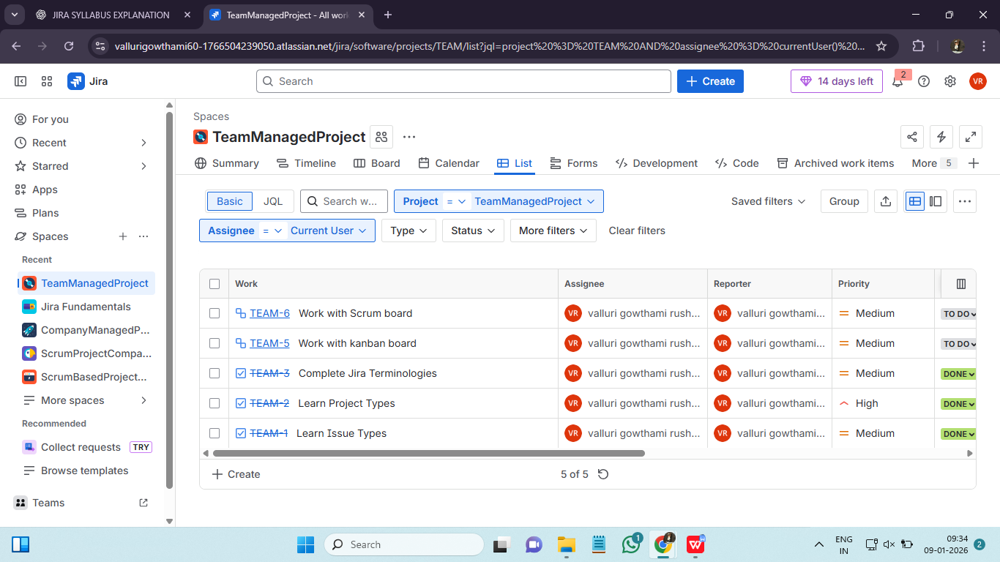

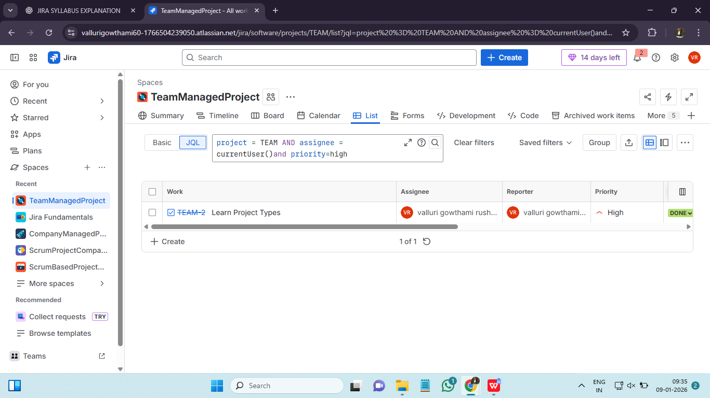

Creating and Saving Filters in Jira for Quick Access ::
A filter is a saved search. Instead of rebuilding same search everyday we can save it once and resue it. Jira filters = Saved view of issues. We use filters because of :
- Save time
- Create personal worklist
- Share views with teammates
- Power dashboards and reports
We can manage filters by starring it, renaming it. Filters are private by default. Sharing enables collaboration. Filters follow naming convention as [Team] - [Purpose] - [Scope].
Hands on :
- Log in to Jira.
- Click Search for issues.
- Apply search criteria using Basic Search or JQL.
- Verify the search results.
- Click Save As.
- Enter a filter name (and description if needed).
- Click Save.
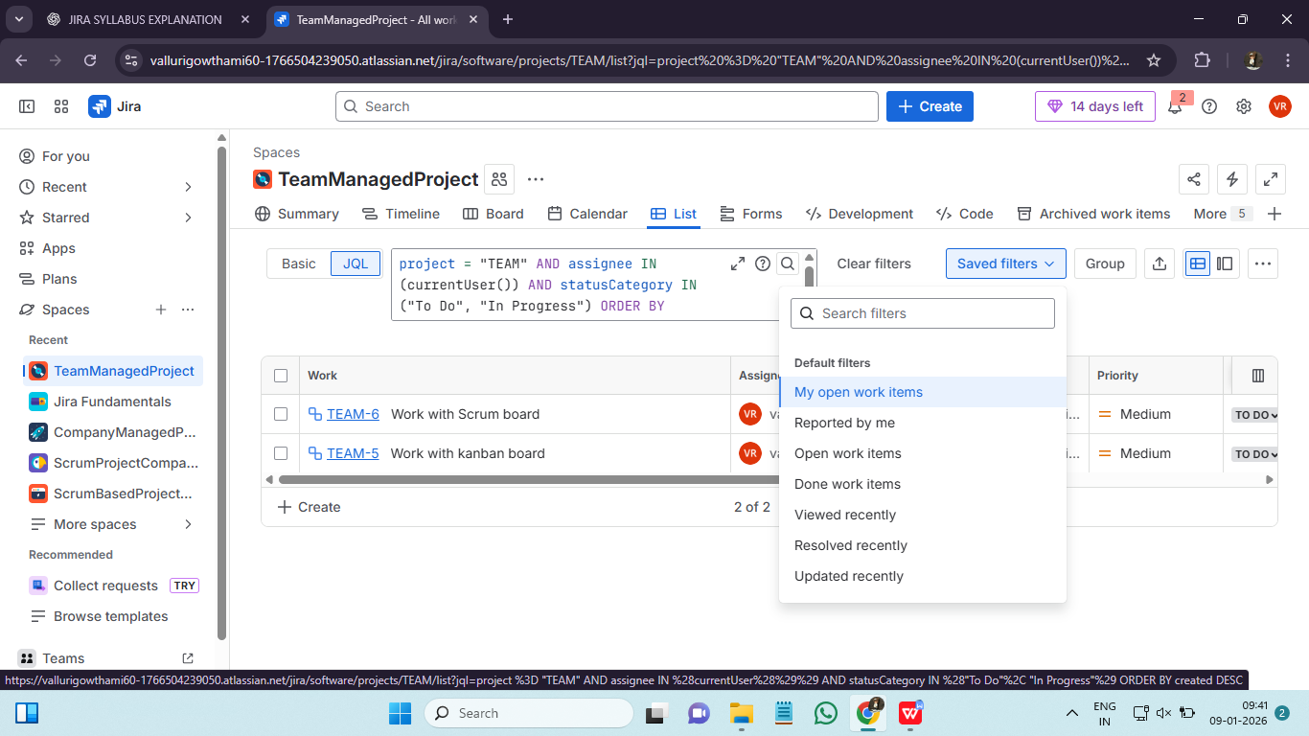

JQL Basics: What is Jira Query Language and Why It Matters ::
Jira Query Language (JQL) is a powerful query language used in Jira to search, filter, and retrieve issues based on specific conditions. Unlike Basic Search, JQL allows more precise and advanced searches. It is an advanced searc for jira issues.
Basic search : Clicking filters
JQL : Writing sentence that jira understands
JQL express complex logic and easy to reuse or automate. JQL allows :
- Precise searches
- Saved filters
- Dashboard
- Automation rules
- Reports
JQL structure is as follows : field - operator - value


Time-Based JQL Queries: Finding Issues by Date and Time ::
Time-based JQL queries are used in Jira to find issues based on dates and time, such as when an issue was created, updated, or resolved. These queries help track progress, monitor activity, and analyze work over a specific period.
Created : Issue opened
Updated : Last time it changed
Resolved : Issue completed
Due date : Target completion date
We can use date functions like StartOfDay() and EndOfDay(). And operators like >=, <=, > , < for caluculating time.

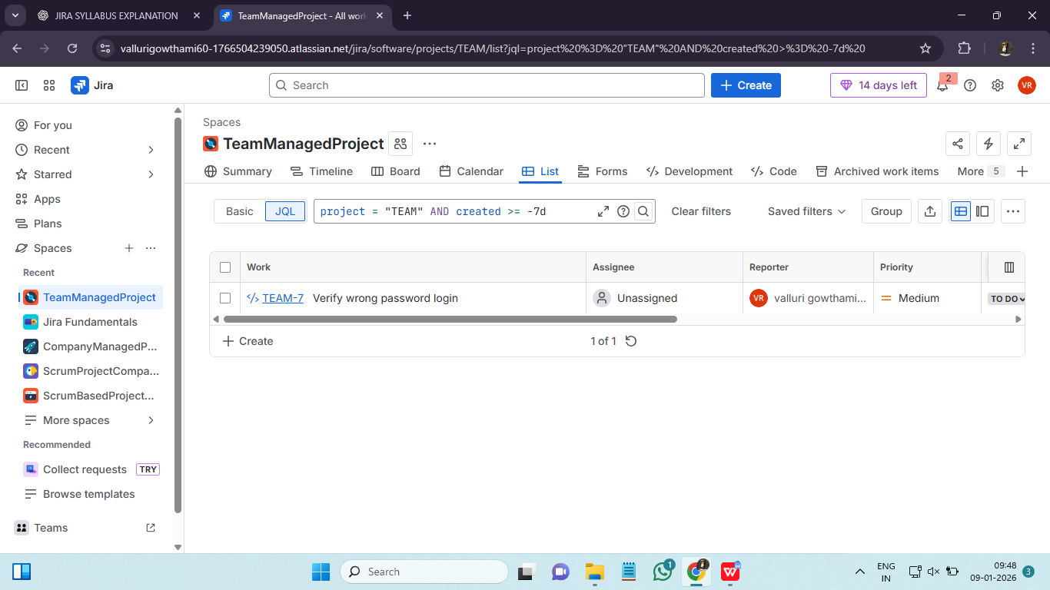

Link-Based and Hierarchy JQL Queries for Advanced Filtering ::
In jira issues can be cinnected either with link or hierarchy. We use link based and hierarchy based JQLs for questions involoving dependencies, impacts and rollups.
Link based JQL : Find issues based on relationships.
Hierarchy based JQL : Find issues based on parent/child structure.
Link-Based JQL Queries
Link-based queries are used to find issues that are connected to other issues through issue links such as blocks, is blocked by, relates to, or duplicates. These queries help track dependencies and identify issues that may affect progress. For example, you can find all issues that block a specific task or all tasks related to a bug.
Ex : issue in linkedIssues(“Proj”) - All issues linked to specific issue.
Ex : issue in linkedIsses(“Proj”, “blocks”) - Only issues blocked by given issue.
Use linked based JQL for :
- Dependency reviews
- Risk & blocker dashboards
- Release readiness checks

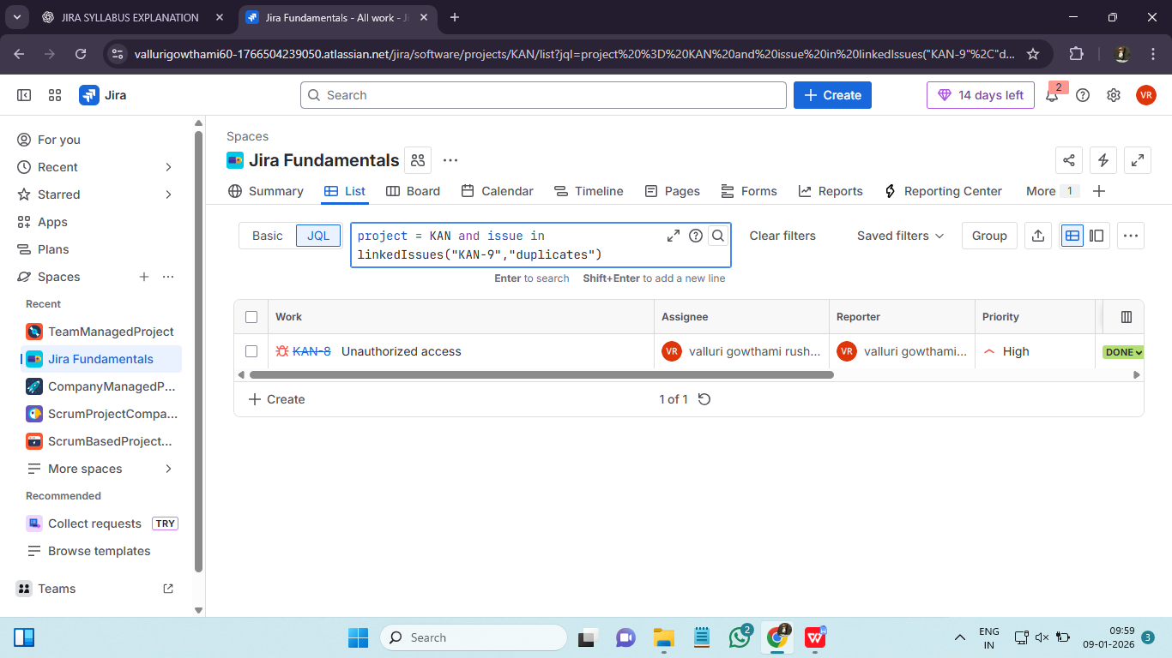
Hierarchy JQL Queries
Hierarchy queries focus on parent–child relationships in Jira. They are used to track work across Epics, Stories, Tasks, and Sub-tasks. Common use cases include finding all stories under an Epic or identifying sub-tasks linked to a parent issue.
Ex : parent = Proj - All subtasks of parent issue
Use Hierarchy based JQL for :
- Epic progress
- Scope control
- Rollup reporting
